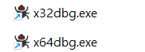
Use x32dbg.exe
https://x64dbg.com/
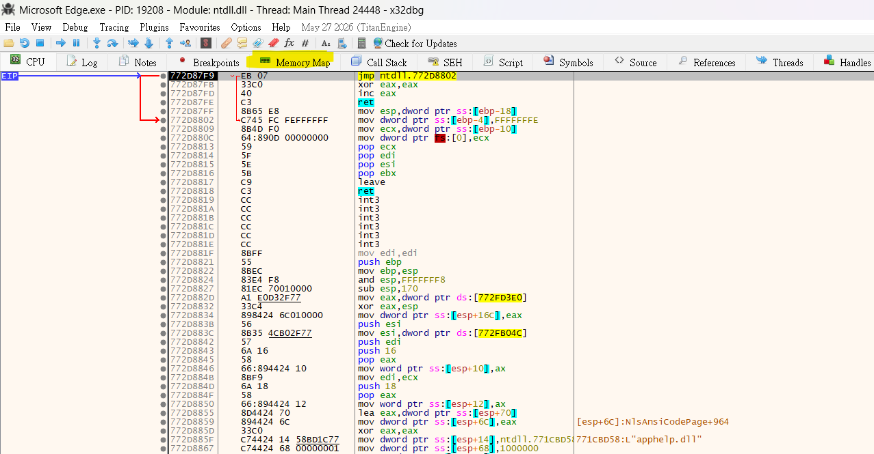
Click into Memory
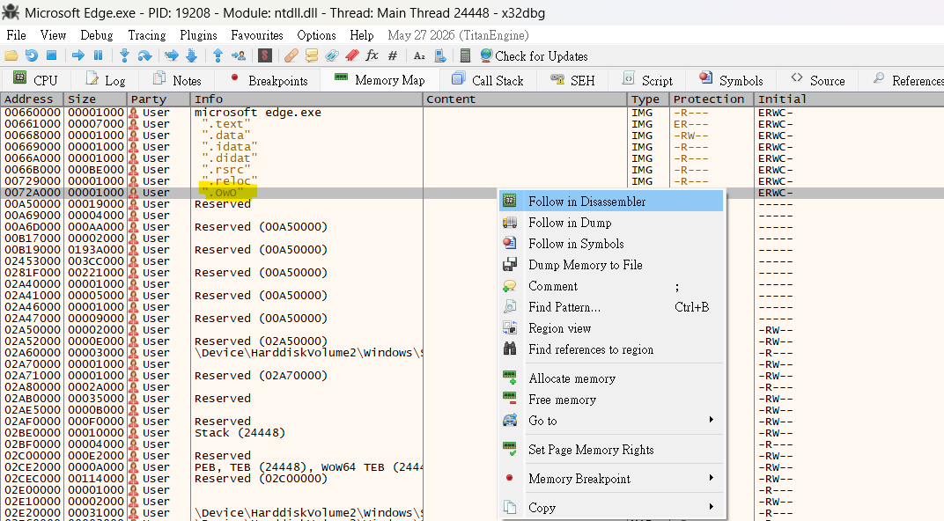
Right click “owo” and click Follow in Disassembler

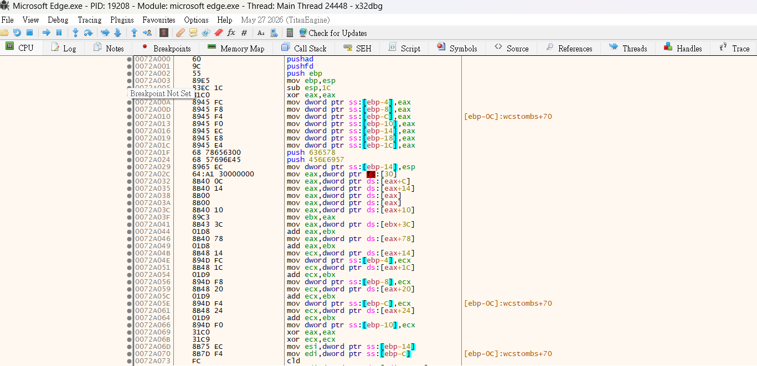
Go down a bit
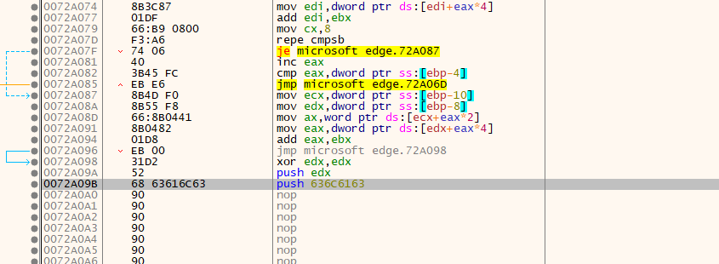
Find Push edx
Push 63616c63 mean calc
0x63 = c
0x61 = a
0x6C = l
0x63 = c
That’s why, when you click this .exe file, Calculator will launch as well.

.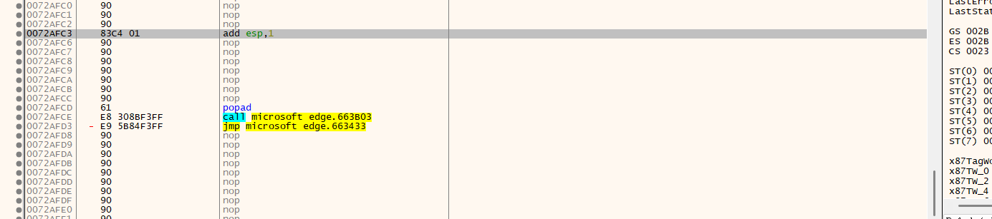
And because it uses 1 push so you need to add 1 in esp.
I put it all the way down here so you maybe need to find it a while.
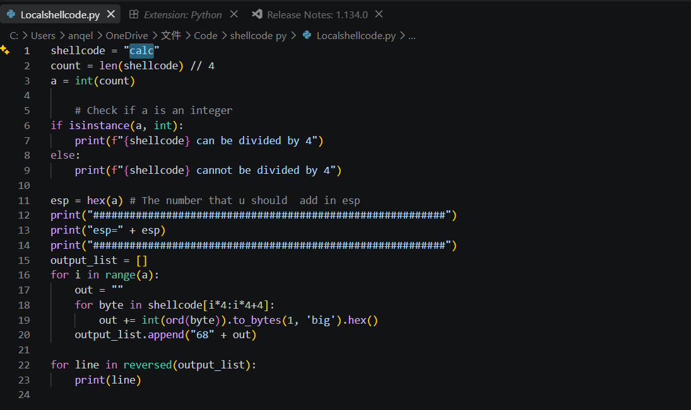
Using this python all u need to do is copy and paste so you can make your own shellcode.
Like this one
cmd.exe /c start https://www.youtube.com
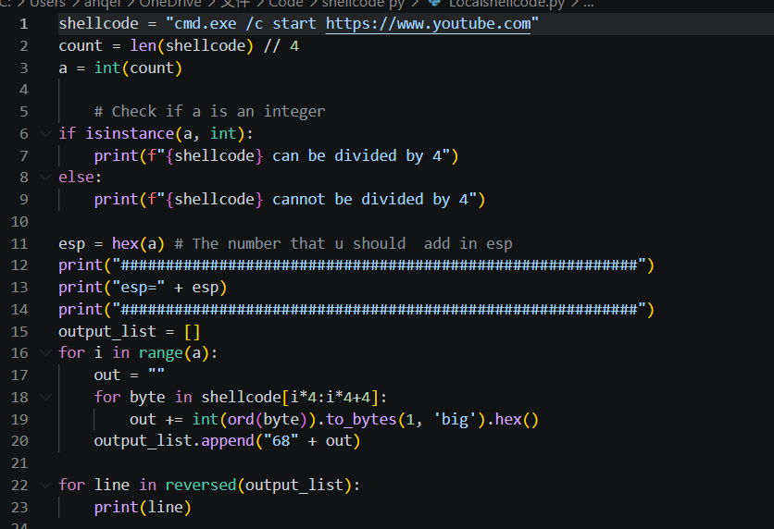
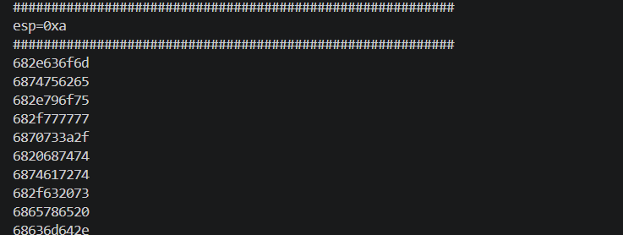
You will get these thing to copy and paste.
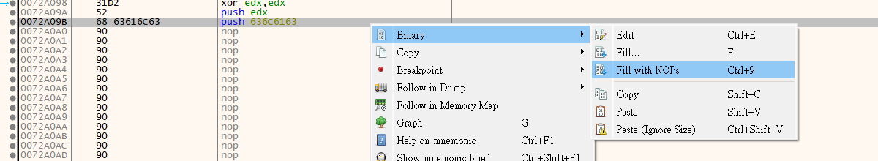
Right click pust 636C163 than click Fill with NOPs in Binary. 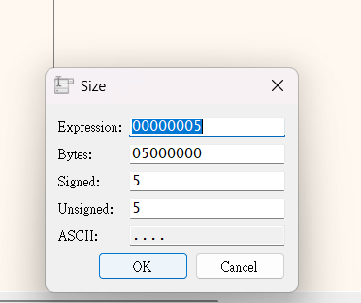
Click ok
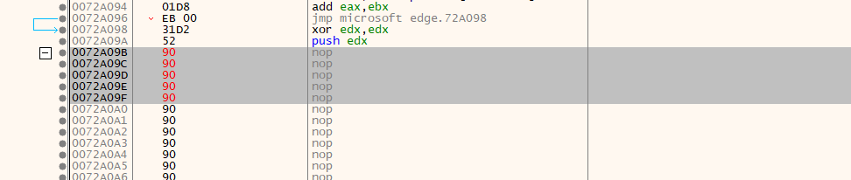
You should see that
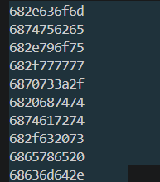
Copy this in python

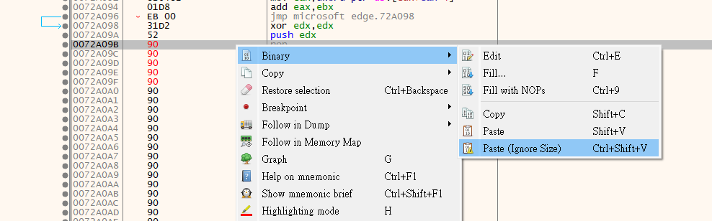
Rick click the 90 under push edx and click paste(Ignore Size)
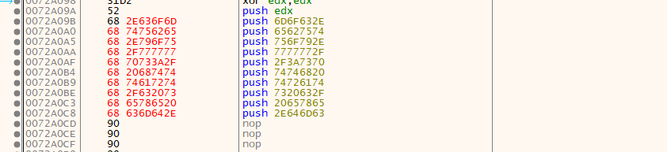
You should see that
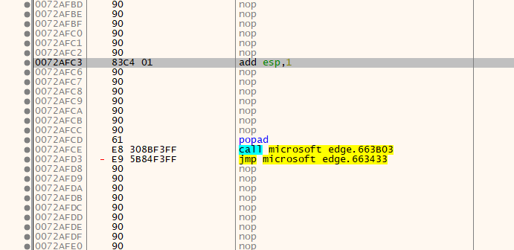
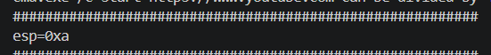
Find the add esp 1 and change it to a
Click it and click space key to change
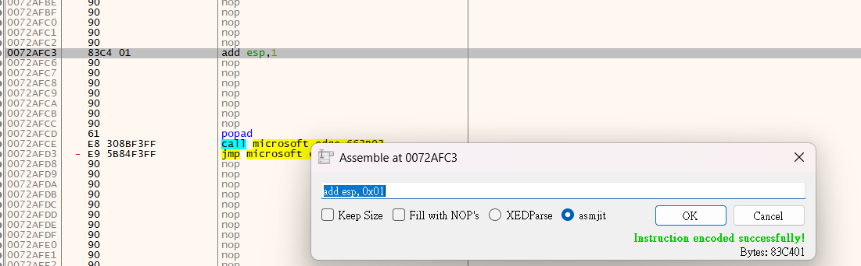
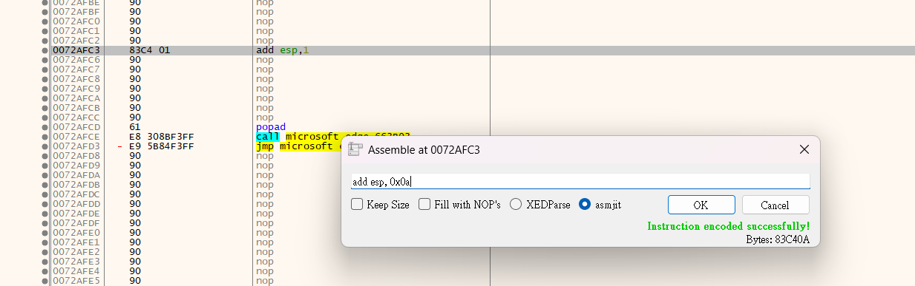
Click ok and click the Cross.
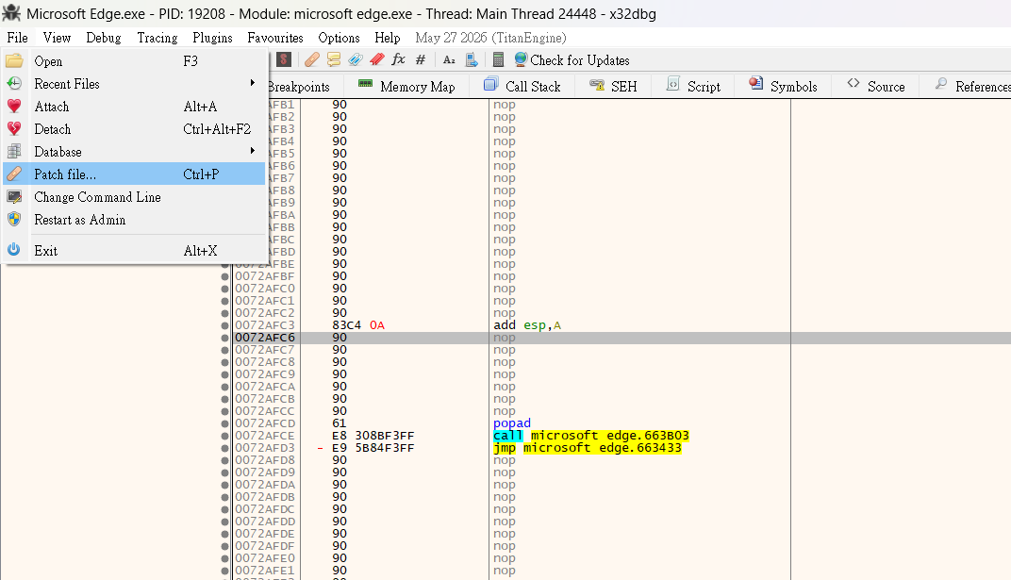
Save it with File > Patch File
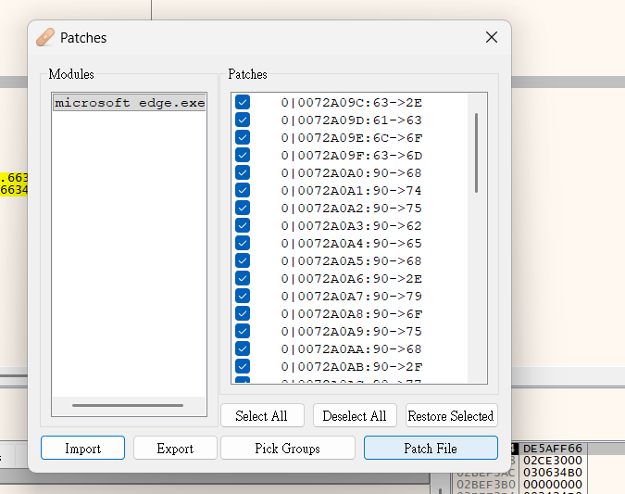
Click Path File
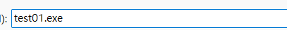
Name it with xxxx.exe. ( must with .exe)

And rung it buy clicking it or using F9 in x32gdb

